|  |
| --- |
| 1. - (1 - x) - (5,1 + x) =_______________________________________________________ |
| 1. - (a - x - 3) - (x - a + 2) =___________________________________________________ |
| 1. (a + 3,3 - a) - (3,3 + x) =________________________________________________ |
| 1. - (2,43 + x - b) - (2,43 + b - x) =_________________________________________ |
| 1. - (1,53 - x + 1) - (x - a - 2,53) =_________________________________________ |

Раскройте скобки и упростите:

|  |  |  |
| --- | --- | --- |
| 1. -(a - x) - (5,1 + x) + a - 5,1 =________________________________________________ | |  |
| 1. (b - x) - (a - x) + (a - b) =__________________________________________________________ | |  |
| 1. -(a + 3,3) - (x - a) - 3,3 + x =_______________________________________________________ | |  |
| 1. (2,43 + 1,1) - (b + 2,43) + (b - 1,1) =_________________________________________________ | |  |
| 1. - (1,53 - x + a) - (x - 1,53 - a) - a =___________________________________________________ | |  |
| 1. (2 - 1,51) - (3,13 - 0,51) + (0,13 - 0,5) =______________________________________________ | |  |
| 1. -(0,39 + 2,1) + (0,13 • 3 - 2,1) - 0,8 =_________________________________________________ | |  |
| 1. (4,3918 - 16,4) - (4,3917 - 4,1 • 4) =__________________________________________________ | |  |
| 1. (3,29 + 1) - (1,2 + 1) - (1 - 0,91) =___________________________________________________ | |  |
| 1. - (a - 1,21) - (1 - a) - (0,21 - a) =_____________________________________________________ | |  |
| 1. 3,1a - 0,3a - 4,8a =________________________________________________________________ |  |
| 1. 4,5b - 5c - (5,5b - 5c) =____________________________________________________________ |  |
| 1. 3,8a - 1,2b - ( 1,1b + 3,8a) =________________________________________________________ |  |
| 1. 1,8a - (1,8a - 1,05c) - (1,05c - 0,9a) =_________________________________________________ |  |
| 1. - (5,6c - 4,1b) - (4,1b - 5,6c) =_______________________________________________________ |  |

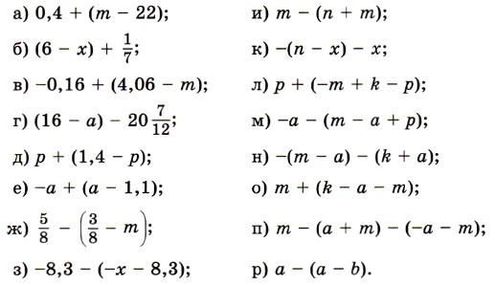

|  |
| --- |
| 1. - (1 - x) - (5,1 + x) =_______________________________________________________ |
| 1. - (a - x - 3) - (x - a + 2) =___________________________________________________ |
| 1. (a + 3,3 - a) - (3,3 + x) =________________________________________________ |
| 1. - (2,43 + x - b) - (2,43 + b - x) =_________________________________________ |
| 1. - (1,53 - x + 1) - (x - a - 2,53) =_________________________________________ |

Раскройте скобки и упростите:

|  |  |  |
| --- | --- | --- |
| 1. -(a - x) - (5,1 + x) + a - 5,1 =________________________________________________ | |  |
| 1. (b - x) - (a - x) + (a - b) =__________________________________________________________ | |  |
| 1. -(a + 3,3) - (x - a) - 3,3 + x =_______________________________________________________ | |  |
| 1. (2,43 + 1,1) - (b + 2,43) + (b - 1,1) =_________________________________________________ | |  |
| 1. - (1,53 - x + a) - (x - 1,53 - a) - a =___________________________________________________ | |  |
| 1. (2 - 1,51) - (3,13 - 0,51) + (0,13 - 0,5) =______________________________________________ | |  |
| 1. -(0,39 + 2,1) + (0,13 • 3 - 2,1) - 0,8 =_________________________________________________ | |  |
| 1. (4,3918 - 16,4) - (4,3917 - 4,1 • 4) =__________________________________________________ | |  |
| 1. (3,29 + 1) - (1,2 + 1) - (1 - 0,91) =___________________________________________________ | |  |
| 1. - (a - 1,21) - (1 - a) - (0,21 - a) =_____________________________________________________ | |  |
| 1. 3,1a - 0,3a - 4,8a =________________________________________________________________ |  |
| 1. 4,5b - 5c - (5,5b - 5c) =____________________________________________________________ |  |
| 1. 3,8a - 1,2b - ( 1,1b + 3,8a) =________________________________________________________ |  |
| 1. 1,8a - (1,8a - 1,05c) - (1,05c - 0,9a) =_________________________________________________ |  |
| 1. - (5,6c - 4,1b) - (4,1b - 5,6c) =_______________________________________________________ |  |

